

FDA Medication Guides Project
Java Component
(On-Demand Viewing)

INSTALLATION GUIDE

PSS*1*158
PSN*4*263
PSO*7*343
PSS*1*177
PSN*4*364

April 2011
(Revised December 2014)

Department of Veterans Affairs
Product Development

Revision History

Date | Revision | Description | Author
12/2014 | 1.0.1.0 | Support the new secure CMOP Server using HTTPS functionality released with patches PSS*1*177 and PSN*4*364 and made formatting changes. | Enterprise Application Maintenance team
04/2011 | 1.0 | Original Version | Bob Thomas

(This page included for two-sided copying.)
Table of Contents

Revision History i
Purpose 1
Scope 1
Before You Begin 1
Section 1: Pre-Installation 2
Documentation 2
System Requirements 2
User Interfaces 3
Hardware Interfaces 3
Software Interfaces 3
User Characteristics 3
Acronyms 4
Dependencies and Constraints 4
Data Dictionary Updates 4
For NDF 4
For VA Medical Center 5
Section 2: Installation of Patches and Java Component 6
Installing PSS*1*158 6
Installing PSN*4*263 8
Installing PSO*7*343 10
Installing PSS*1*177 12
Installing the Java Software Component 14

(This page included for two-sided copying.)

Purpose

The purpose of this Installation Guide is to provide an explanation of the installation and implementation process for the Food and Drug Administration (FDA) Medication Guides Increment 2 project.

The intended audience for this document is the Information Resources Management Service (IRMS) staff responsible for installing patches and Outpatient Pharmacy staff responsible for maintaining the pharmacy files.

Scope
The Outpatient Pharmacy application is being modified to allow pharmacists to manually display FDA Medication Guides for a specific prescription when one is available. The National Drug File application is also being modified to allow users to retrieve and print the FDA Medication Guides for specific VA Product entries when one is available. A Java software component is being created specifically for this project to allow the retrieval of the FDA Medication Guide from a web server repository via a web browser. This software must be installed in the user’s computer for the functionality to work correctly.



Before You Begin
This document is organized into two major sections: “Pre-Installation” and “Installation of Patches and Java Component.”

It is expected that most sites will install the software and not immediately implement the new interface. This approach is recommended.

Having the proper setup of parameters and settings is critical to the success of the implementation.

Section 1: Pre-Installation

This section provides information that helps you determine patch and system requirements before installing the patches that are included in this project. It also helps you understand the updates that the installation process makes. Additionally, descriptions are provided regarding the specific parameters that you must set up to implement the interface.

Documentation

Documentation distributed with the FDA Medication Guide project includes the following and may be retrieved from the VISTA Documentation Library (VDL) on the Internet at the following address: http://www.va.gov/vdl.

File Names Description
PSO_7_PHAR_UM_R0411.pdf Outpatient Pharmacy User Manual
PSO_7_P343_PHARM_UM_CP.pdf Outpatient Pharmacy User Manual Change Pages
PSO_7_TM_R0411.pdf Outpatient Pharmacy Technical Manual
PSO_7_P343_TM_CP.pdf Outpatient Pharmacy Technical Manual Change Pages
PSN_4_UM_R0411.pdf National Drug File User Manual
PSN_4_P263_UM_CP.pdf National Drug File User Manual Change Pages
PHAR_FDA_MED_GUIDE_OnDemand_1_0_1_0_IG.pdf FDA Medication Guides Project Installation Guide

System Requirements

The FDA Medication Guide project operates on standard hardware platforms used by the Veterans Health Administration (VHA) facilities and requires the following Department of Veterans Affairs (VA) software packages to support the enhancements in this project. The new interface requires that the Department of Veterans Affairs (VA) software packages and the latest version and most current released patches of the HL7, Inpatient Medications, Drug Accountability, Bar Code Medication Administration, and Controlled Substances applications must be running on the VistA server.

New functionality is being added to the Outpatient Pharmacy V.7.0, Pharmacy Data Management V.1.0 and National Drug File V.4.0 applications to allow users to manually display the associated FDA Medication Guide for a specific prescription or a VA Product, if one is available.

Package | Minimum Version Needed
VA FileMan | 22.0
Kernel | 8.0
MailMan | 8.0
Health Level 7 | 1.6
Order Entry/Results Reporting | 3.0
Inpatient Medications | 5.0
Nursing | 4.0
Outpatient | 7.0
Pharmacy Data Management | 1.0
Controlled Substances | 3.0
Toolkit | 7.3
Drug Accountability | 3.0
BCMA | 3.0

The above software is not included in the Master Build and must be installed before the build is completely functional.

User Interfaces

This software product will conform to the existing VistA conventions found in the Outpatient Pharmacy package. The reports, option and screen formats will conform to the existing VistA conventions. Report formats and option process steps, such as “roll & scroll” will be field tested for usability by test site personnel to ensure that all new functionality meets the needs of the VHA user.

Hardware Interfaces

The product will run on standard hardware platforms that Department of Veterans Affairs Healthcare facilities use. These systems consist of standard or upgraded Alpha AXP clusters and operate either VMS or NT and Open M products.

The primary hardware interface to consider in this enhancement is the software settings that will drive the printing of FDA Medication Guides.

Software Interfaces

An interface between Outpatient Pharmacy V.7.0 and NDF V.4.0 is required to manage the FDA Medication Guide output for this enhancement. Existing interfaces with other applications to support prescription processing will be maintained for this enhancement.

User Characteristics

The intended users of the FDA Medication Guide Project will include pharmacists, pharmacy technicians, and veteran patients and their families.

Acronyms

Term | Definition
API | Application Programming Interface
CFR | Code of Federal Regulations
CMOP | Consolidated Mail Outpatient Pharmacy
FDA | Food and Drug Administration
NDC | National Drug Code
NDF | National Drug File
OPAI | Outpatient Pharmacy Automation Interface
PDF | Portable Document Format
PMI | Patient Medication Information
PBM | Pharmacy Benefits Management
PSN | National Drug File Application Namespace
PSO | Outpatient Pharmacy Application Namespace
URL | Uniform Resource Locator
VistA | Veterans Health Information Systems and Technology Architecture
SDD | Software Design Document

Dependencies and Constraints

Pharmacy Benefits Management (PBM) policies and FDA regulations exist that define which prescriptions contain FDA Medication Guides. These should not be modified without guidance from PBM.

Data Dictionary Updates

For NDF

Modified Routines
The following routines were modified:
- PSNMEDG
- PSNFDAMG
- PSNAPIS

Modified Field
The following new field was added to the VA PRODUCT File (#50.68):
- FDA MED GUIDE field (#100)

Modified Menu Option
The following menu option was modified:
- Display FDA Medication Guide [PSN MED GUIDE]

For VA Medical Center

New Routine
The following new routine was added:
- PSOFDAMG

New Protocol
The following new protocol was added:
- PSO LM DISPLAY FDA MED GUIDE

Modified Protocol
The following protocol was modified:
- PSO LM HIDDEN OTHER #2

New Field
The following new field was added to the PHARMACY SYSTEM File (#59.7):
- FDA MED GUIDE SERVER URL (#100)
Section 2: Installation of Patches and Java Component

This installation is comprised of PSS*1*158, PSN*4*263, PSO*7*343 and a Java software component. Please read the following installation instructions carefully before beginning the installation.

Patches should be installed in the following order:
- PSS*1*158
- PSN*4*263
- PSO*7*343
- PSS*1*177

Installing PSS*1*158

Installation will take less than 2 minutes. It is recommended that installation be queued for off peak hours.

To install PSS*1*158

- Use the INSTALL/CHECK MESSAGE option on the PackMan menu.
- From the Kernel Installation & Distribution System (KIDS) menu, select the Installation menu
- From this menu, you may select to use the following options (when prompted for INSTALL NAME, enter PSS*1.0*158).
  - Backup a Transport Global - This option will create a backup message of any routines exported with the patch. It will NOT back up any other changes such as DDs or templates.
  - Compare Transport Global to Current System - This option will allow you to view all changes that will be made when the patch is installed. It compares all components of the patch (routines, DDs, templates, etc.).
  - Verify Checksums in Transport Global - This option will ensure the integrity of the routines that are in the transport global.
  - Print Transport Global - This option will allow you to view the components of the KIDS build.
- Use the Install Package(s) option and select the package PSS*1.0*158.
- When prompted "Want KIDS to INHIBIT LOGONs during the install? NO//" respond NO.
- When prompted "Want to DISABLE Scheduled Options, Menu Options, and Protocols? NO//" respond NO.
Example of PSS*1*158 Installation
Select Installation Option: INSTall Package(s)
Select INSTALL NAME: PSS*1.0*158 Loaded from Distribution 9/14/10@16:36:43
=> PSS*1*158 TEST v1
This Distribution was loaded on Sep 14, 2010@16:36:43 with header of
PSS*1*158 TEST v1
It consisted of the following Install(s):
PSS*1.0*158
Checking Install for Package PSS*1.0*158

Install Questions for PSS*1.0*158

Incoming Files:

59.7 PHARMACY SYSTEM (Partial Definition)
Note: You already have the 'PHARMACY SYSTEM' File.

Want KIDS to INHIBIT LOGONs during the install? NO//
Want to DISABLE Scheduled Options, Menu Options, and Protocols? NO//

Enter the Device you want to print the Install messages.
You can queue the install by enter a 'Q' at the device prompt.
Enter a '^' to abort the install.

DEVICE: HOME// GENERIC INCOMING TELNET

Install Started for PSS*1.0*158 :
Sep 14, 2010@16:38:53

Build Distribution Date: Sep 14, 2010

PSS*1.0*158
────────────────────────────────────────────────────────────────────────────────
Installing Routines:
Sep 14, 2010@16:38:53

Installing Data Dictionaries: .
Sep 14, 2010@16:38:54

Running Post-Install Routine: ^PSS158P

Updating Routine file...

Updating KIDS files...

PSS*1.0*158 Installed.
Sep 14, 2010@16:38:54

Not a production UCI

NO Install Message sent
────────────────────────────────────────────────────────────────────────────────
┌────────────────────────────────────────────────────────────┐
100% │ 25 50 75 │
Complete └────────────────────────────────────────────────────────────┘

Install Completed

Installing PSN*4*263

Installation will take less than 2 minutes. It is recommended that installation be queued for off peak hours.

To install PSN*4*263

- Use the INSTALL/CHECK MESSAGE option on the PackMan menu.
- From the Kernel Installation & Distribution System (KIDS) menu, select the Installation menu.
- From this menu, you may select to use the following options (when prompted for INSTALL NAME, enter PSN*4.0*263).
  - Backup a Transport Global - This option will create a backup message of any routines exported with the patch. It will NOT back up any other changes such as DDs or templates.
  - Compare Transport Global to Current System - This option will allow you to view all changes that will be made when the patch is installed. It compares all components of the patch (routines, DDs, templates, etc.).
  - Verify Checksums in Transport Global - This option will ensure the integrity of the routines that are in the transport global.
  - Print Transport Global - This option will allow you to view the components of the KIDS build.
- Use the Install Package(s) option and select the package PSN*4.0*263.
- When prompted "Want KIDS to INHIBIT LOGONs during the install? NO//" respond NO.
- When prompted "Want to DISABLE Scheduled Options, Menu Options, and
- Protocols? NO//" respond NO.
Example of PSN*4*263 Installation
Select Installation Option: INStall Package(s)
Select INSTALL NAME: PSN*4.0*263 Loaded from Distribution 9/14/10@16:37:
37
=> PSN*4*263 TEST v1

This Distribution was loaded on Sep 14, 2010@16:37:37 with header of
PSN*4*263 TEST v1
It consisted of the following Install(s):
PSN*4.0*263
Checking Install for Package PSN*4.0*263

Install Questions for PSN*4.0*263

Want KIDS to INHIBIT LOGONs during the install? YES// NO
Want to DISABLE Scheduled Options, Menu Options, and Protocols? NO// NO

Enter the Device you want to print the Install messages.
You can queue the install by enter a 'Q' at the device prompt.
Enter a '^' to abort the install.

DEVICE: HOME// GENERIC INCOMING TELNET

PSN*4.0*263
────────────────────────────────────────────────────────────────────────────────
Install Started for PSN*4.0*263 :
Sep 14, 2010@16:40:55

Build Distribution Date: Sep 14, 2010

Installing Routines:
Sep 14, 2010@16:40:56

Updating Routine file...

Updating KIDS files...

PSN*4.0*263 Installed.
Sep 14, 2010@16:40:56

Not a production UCI

NO Install Message sent
────────────────────────────────────────────────────────────────────────────────
┌────────────────────────────────────────────────────────────┐
100% │ 25 50 75 │
Complete └────────────────────────────────────────────────────────────┘

Install Completed

Installing PSO*7*343

Installation will take less than 2 minutes. It is recommended that installation be queued for off peak hours.

To install PSO*7*343:

- Use the INSTALL/CHECK MESSAGE option on the PackMan menu.
- From the Kernel Installation & Distribution System (KIDS) menu, select the Installation menu.
- From this menu, you may select to use the following options (when prompted for INSTALL NAME, enter PSO*7.0*343).
  - Backup a Transport Global - This option will create a backup message of any routines exported with the patch. It will NOT back up any other changes such as DDs or templates.
  - Compare Transport Global to Current System - This option will allow you to view all changes that will be made when the patch is installed. It compares all components of the patch (routines, DDs, templates, etc.).
  - Verify Checksums in Transport Global - This option will ensure the integrity of the routines that are in the transport global.
  - Print Transport Global - This option will allow you to view the components of the KIDS build.
- Use the Install Package(s) option and select the package PSO*7.0*343.
- When prompted "Want KIDS to INHIBIT LOGONs during the install? NO//" respond NO.
- When prompted "Want to DISABLE Scheduled Options, Menu Options, and Protocols? NO//" respond NO.

Example of PSO*7*343 Installation
Select Installation Option: INStall Package(s)
Select INSTALL NAME: PSO*7.0*343 Loaded from Distribution 9/14/10@16:37:2
4
=> PSO*7*343 TEST v1

This Distribution was loaded on Sep 14, 2010@16:37:24 with header of
PSO*7*343 TEST v1
It consisted of the following Install(s):
PSO*7.0*343
Checking Install for Package PSO*7.0*343

Install Questions for PSO*7.0*343

Want KIDS to INHIBIT LOGONs during the install? NO//
Want to DISABLE Scheduled Options, Menu Options, and Protocols? NO//

Enter the Device you want to print the Install messages.
You can queue the install by enter a 'Q' at the device prompt.
Enter a '^' to abort the install.

DEVICE: HOME// GENERIC INCOMING TELNET

Install Started for PSO*7.0*343 :
Sep 14, 2010@16:41:25

Build Distribution Date: Sep 14, 2010

Installing Routines:
PSO*7.0*343
────────────────────────────────────────────────────────────────────────────────
Sep 14, 2010@16:41:25

Installing PACKAGE COMPONENTS:

Installing PROTOCOL
Located in the PSO (OUTPATIENT PHARMACY) namespace.
Sep 14, 2010@16:41:26

Updating Routine file...

Updating KIDS files...

PSO*7.0*343 Installed.
Sep 14, 2010@16:41:26

Not a production UCI

NO Install Message sent
────────────────────────────────────────────────────────────────────────────────
┌────────────────────────────────────────────────────────────┐
100% │ 25 50 75 │
Complete └────────────────────────────────────────────────────────────┘

Install Completed!

Installing PSS*1*177

Patch installation will take less than 1 minute. This patch may be installed at any time with users on the system.

To install PSS*1*177

- Use the INSTALL/CHECK MESSAGE option on the PackMan menu.
- From the Kernel Installation & Distribution System (KIDS) menu, select the Installation menu
- From this menu, you may select to use the following options (when prompted for INSTALL NAME, enter PSS*1.0*177).
  - Backup a Transport Global - This option will create a backup message of any routines exported with the patch. It will NOT back up any other changes such as DDs or templates.
  - Compare Transport Global to Current System - This option will allow you to view all changes that will be made when the patch is installed. It compares all components of the patch (routines, DDs, templates, etc.).
  - Verify Checksums in Transport Global - This option will ensure the integrity of the routines that are in the transport global.
  - Print Transport Global - This option will allow you to view the components of the KIDS build.
- Use the Install Package(s) option and select the package PSS*1.0*177.
- When prompted "Want KIDS to INHIBIT LOGONs during the install? NO//" respond NO.
- When prompted "Want to DISABLE Scheduled Options, Menu Options, and Protocols? NO//" respond NO.

Example of PSS*1*177 Installation
Select Installation Option: Install Package(s)
Select INSTALL NAME: PSS*1.0*177 1/7/14@12:48:03
=> Completed/NotReleased PSS*1*177

This Distribution was loaded on Jan 07, 2014@12:48:03 with header of
Completed/NotReleased PSS*1*177
It consisted of the following Install(s):
PSS*1.0*177
Checking Install for Package PSS*1.0*177

Install Questions for PSS*1.0*177

Want KIDS to INHIBIT LOGONs during the install? NO//
Want to DISABLE Scheduled Options, Menu Options, and Protocols? NO//

Enter the Device you want to print the Install messages.
You can queue the install by enter a 'Q' at the device prompt.
Enter a '^' to abort the install.

DEVICE: HOME// VIRTUAL TELNET

PSS*1.0*177


Installing Routines:
Jan 07, 2014@13:19:17

Running Post-Install Routine: POST^PSS177P

FDA MED GUIDE SERVER URL UPDATE COMPLETE.

Updating Routine file...

Updating KIDS files...

PSS*1.0*177 Installed.
Jan 07, 2014@13:19:18

Not a production UCI

NO Install Message sent
────────────────────────────────────────────────────────────────────────────────
┌────────────────────────────────────────────────────────────┐
100% │ 25 50 75 │
Complete └────────────────────────────────────────────────────────────┘

Install Completed!

Installing the Java Software Component

Installation will take about 5 to 10 minutes and must be performed on every computer where the user needs to retrieve and display an FDA Medication Guide.

Note: Administrator-level permissions are required to install the software on the individual workstations.

Upgrading to a new version of the On-Demand Component:

If an old version of the On-Demand Java software component already exists on the workstation, the following steps need to be performed.

- Uninstall the old version of the On-Demand Med Guide Viewer software by following the instructions given in the Uninstall section.
- Then install the new version On-Demand Med Guide Viewer software by following the instructions given in the Install section.

Uninstalling the On-Demand Component:

- To remove the software from your PC, use the standard Add/Remove applet provided by Windows.
    - Click on the Start button.
    - Select Control Panel.
    - Select the Add or Remove Programs applet in the Control Panel.
    - Scroll down to the listings in the applet starting with the letter “O”.
    - Choose the On-demand Med Guide Viewer entry as shown below:
    - Click on the Remove button.
    - A removal tool appears on the screen indicating that the software has been removed.
- Reboot

Example of Uninstalling Java Software
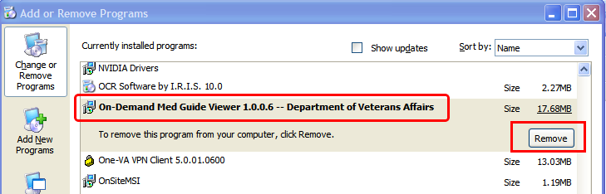

Installing the On-Demand Component:

To install and test the On-Demand Med Guide Viewer software, follow these instructions.

- Installing the software.
  - Prepare the software
    - Since the On-Demand Med Guide Viewer software is a Java application, it requires that the Java SE Runtime Environment (JRE) be installed on your PC. The JRE is not distributed as part of this package and must be separately downloaded from the Oracle website (http://www.java.com.). Java Standard Edition (SE) 1.6, or newer, is required. If Java SE 1.6 is already installed on your PC, you may skip this step.
    - The Java component is distributed as a ZIP-compressed file (PSN_4_P364.zip) containing a single EXE executable file. Unzip the file contents into a temporary folder of your choice. After successfully installed, the zip file and setup file may be deleted.

  - Run the executable installer.
- Locate the file named “On-Demand_Med_Guide_Viewer-x.x.x.x_setup.exe” (x.x.x.x represents a four digit version number separated by dots.)
- Double-click on the file name to start/run the installer.
- The installer detects whether you already have a compatible version of Java installed on your PC. If not, the installer aborts and prompts you to download and install Java from the Oracle website.
- When JRE installation is complete, close the residual installer window.
  - Reboot, when prompted to do so and continue.

Example of On-Demand Installation

If JRE is not already installed, the following prompt will occur:
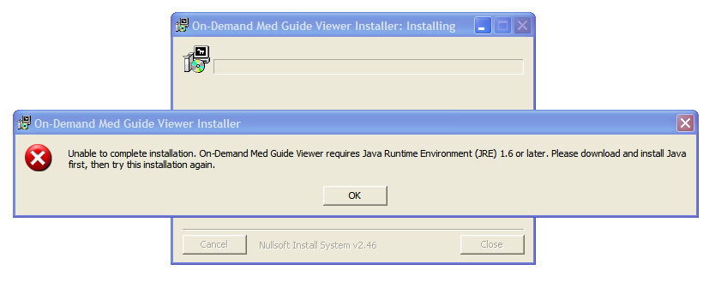
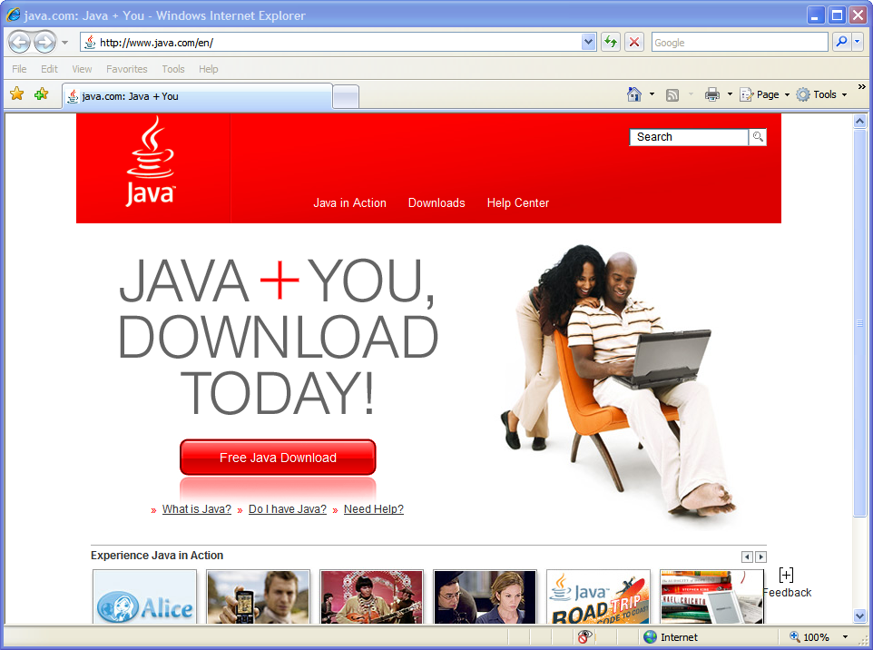

If JRE is already installed, the prompt will not occur:
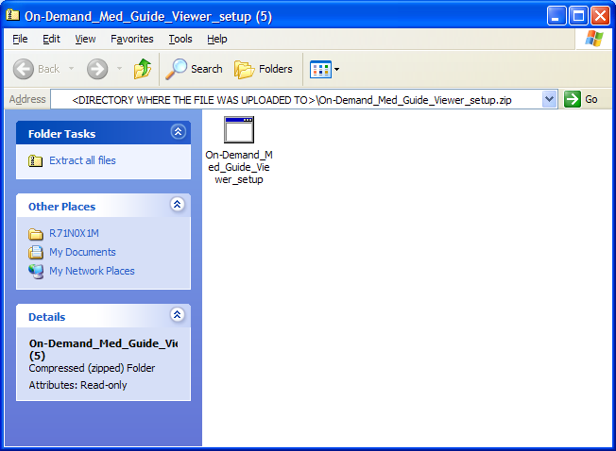

Example of On-Demand Installation (continued)
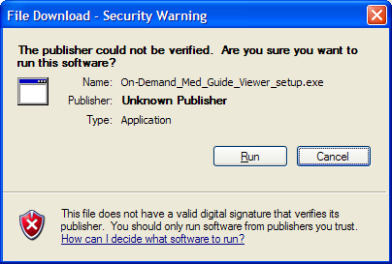

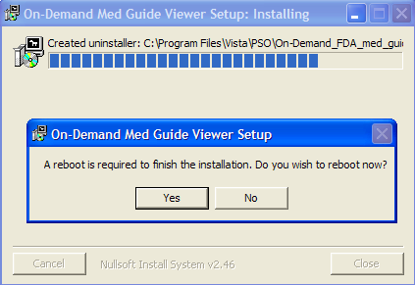

Example of installed On-Demand Viewer Java Software version 1.0.1.0
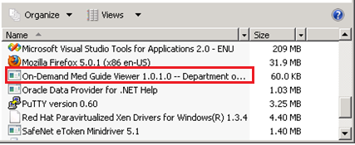

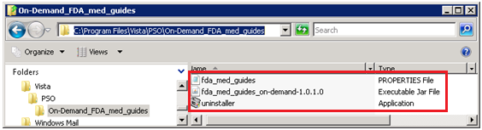

- Test the installation and the application software.
  - Logon to Vista using the roll-scroll interface.

  - Request display of a specific med guide document from Vista.
    - Test for Outpatient Pharmacy Application users:
      - Logon to the Outpatient Pharmacy Application [PSO MANAGER]
      - Select the Patient Prescription Processing option [PSO LM BACKDOOR ORDERS], a.k.a. “Backdoor Pharmacy”, which is located under the Rx (Prescriptions) menu [PSO RX].
      - Select any Division.
      - Select any Patient.
      - Select one of the patient’s prescriptions with a dispense drug matched to a VA Product that contains an associated FDA Medication Guide.
      - Select hidden action OTH (Other OP Actions).
      - Select Item MG (Display FDA Medication Guide).
    - Test for National Drug File Application users:
      - Logon to the National Drug File Application [PSNMGR].
      - Select the Display FDA Medication Guide option [PSN MED GUIDE].
      - When prompted for ‘VA PRODUCT NAME’, enter a VA Product that contains an associated FDA Medication Guide.

  - After a few seconds, an FDA med guide should display within Adobe Acrobat Reader, embedded within the default Web Browser (Internet Explorer). This is the PDF file that you requested in the previous step. If step ii.3 is successful, the software is correctly installed and properly working.

- Technical details:
- The Java component software will automatically run in the background each time the PC is booted/rebooted. There is no visible evidence that it is running.

- After the software is installed, there are no obvious signs of its presence other than the display of a med guide when requested. When not in use, the software remains silently in the background awaiting instructions. No GUI is associated with the application.

- The software is (by default) typically installed in the folder shown below and contains the files listed in this folder.

- Registry entries affected by this installation are shown below.

Example of On-Demand installation folder
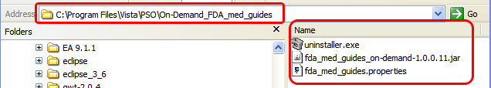

Example of On-Demand Registry Entries
